# TESTING LOGIN JOURNEY

1. Graphical user interface, application, Teams

   Description automatically generatedA screenshot of a cell phone

   Description automatically generated with medium confidenceCorrect user and password

1. Correct email incorrect password

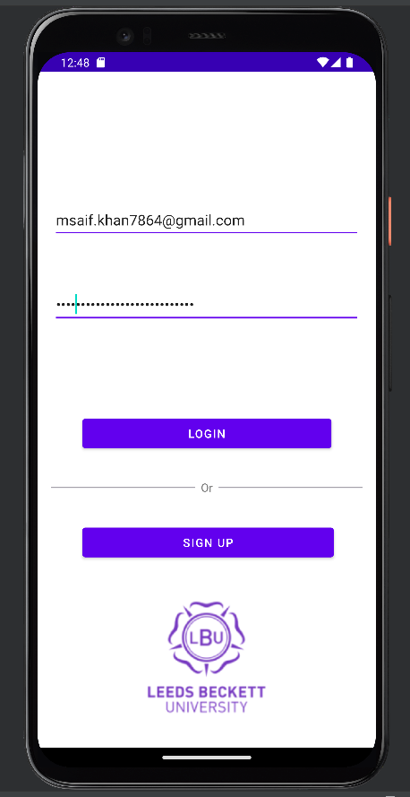

1. Incorrect email and password

